1.For filter status process

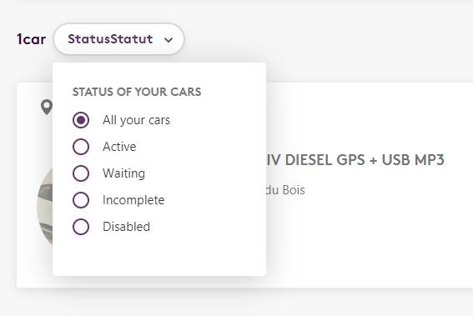

2.we can give some suggestion to partners e.g. below image

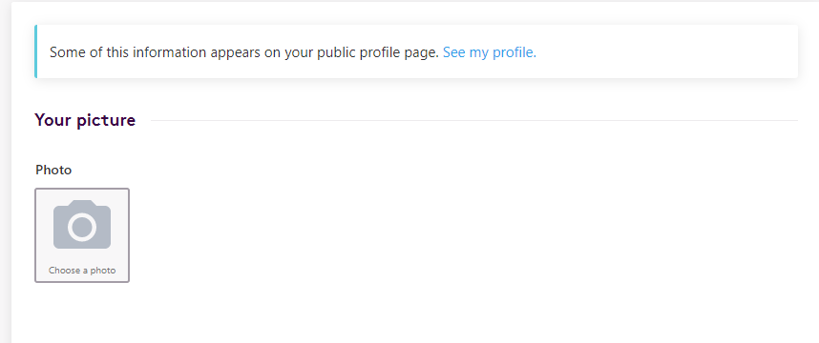

3. we can use like this type of option button for yes or no

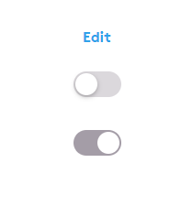

4.using this increase or decrease option

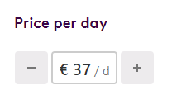

5.We need to get more option

1. Wheelchair accessible
2. With trailer
3. Coupling
4. Snow tires
5. Roof box
6. Bicycle rack
7. Chains
8. Ski carrier
9. Audio / iPod input

6.we can use edit option like this

